**Brooklyn torah gazette**

**For parshas noach 5780**

Volume 4, Issue 7 (Whole Number 159) 4 Cheshvan 5780/ November 2, 2019

**Printed L’illuy nishmas Nechama bas R’ Noach, a”h**

For a free subscription, please forward your request to [***keren18@juno.com***](mailto:keren18@juno.com)

**A Fascinating Irish Jewish Past and an Uncertain Future**

**By Shimon Frais**

[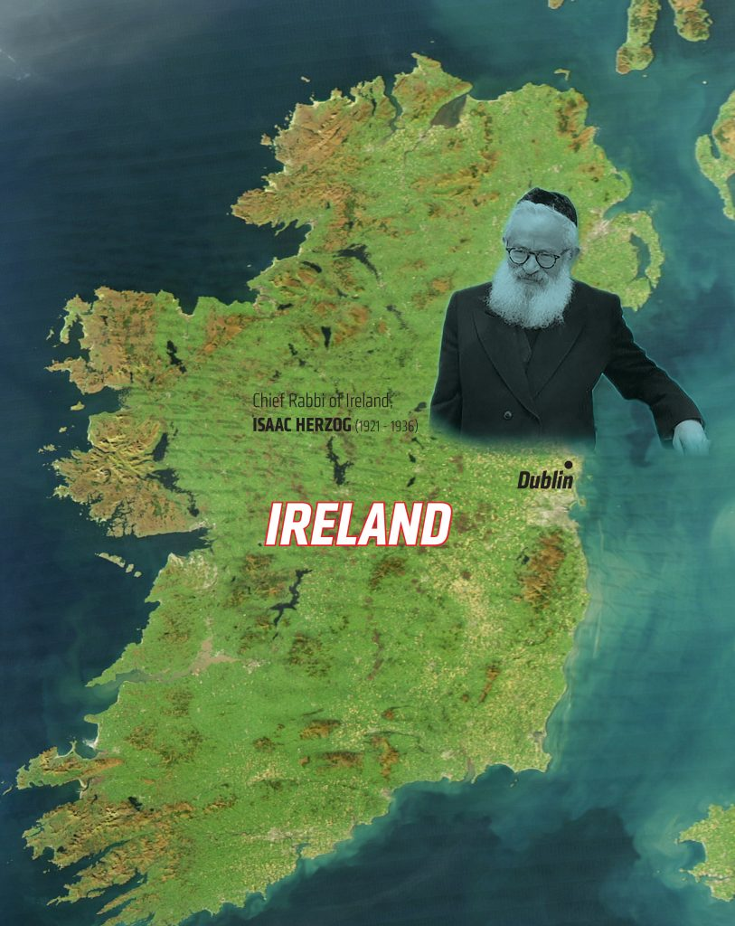](https://images.hamodia.com/hamod-uploads/2019/10/16003350/Main-Image-no-caption2-813x1024.jpg)

*Hungarian and Polish Jews, or, for that matter, Yemenite or Moroccan Jews, are well known, with a great deal written about their history and customs, but raise the subject of the Irish Jew and your listener assumes you are about to tell a joke. No doubt a few people will know that former Chief Rabbi of Mandatory Palestine and then the state of Israel, Isaac Herzog, was previously the Chief Rabbi of Ireland, but with this sole exception they are unlikely to know much else about Jewish life in Ireland.*

**How can you be Jewish and Irish?**

Without doubt, the small size of this Jewish community goes a long way to explaining why Irish Jewry merits little more than a footnote in the long saga of Jewish history. Popular ideas about this country and its inhabitants also make the concept of an Irish Jew seem more than a little incongruous. Many people seem to have the impression that you must be a Catholic, a heavy drinker and a tough brawler to qualify for the title of Irishman.

When I lived in England some 40 years ago, I remember the English made a virtually automatic association between the Irish and bricklayers since so many Irishmen came to England to work in the construction industry. Perhaps Americans would make a similar instant association between the Irish and the archetypical New York police officer.



**A Potted History of Ireland**

From the early medieval period until the 1920s, the whole of the island we call Ireland was ruled by the English. After a revolt in 1916, the 26 southern counties gained their independence — as the Republic of Ireland or Eire. The six counties in the northeast of Ireland remained under English rule as Ulster or Northern Ireland. For the most part the Republic of Ireland is Catholic while Ulster is predominantly Protestant, and this religious divide has led to many years of violent conflict.

**The Last Jews of Ulster**

The Republic of Ireland’s Jewish community has always been the larger one, but the Ulster community also numbered well over 1000 up until the violent unrest in the late 1960s and 1970s. It is interesting to note that Jews were not specifically targeted in this sectarian violence. Apparently, once a Jew was stopped by one of the gangs and asked his religion. When he said he was Jewish, they asked, “But are you a Protestant Jew or a Catholic Jew?”

Yet the damage the unrest caused to the economy and a long period of political uncertainty contributed to the community’s decline. Today the Jewish community in Ulster is a pale shadow of its former self with just a few hundred members. If you see Israeli flags waved in Ulster today they are more likely to be in the hands of Protestant militants than Jews. These Protestants choose to identify with the Israeli side of the struggle simply because the Catholic IRA supports the Palestinian Arabs.



**The First Signs of a Jewish Presence in Ireland**

There is evidence of a small Jewish community in Ireland in the 1200s, but it appears to have disappeared with the 1290 Expulsion from Britain. Jews returned to Ireland in the sixteenth century after the Expulsion from Spain. One of these Sephardic immigrants, William Annyas, was appointed major of Youghal, County Cork, in the 1550s.

Records exist of a synagogue in Dublin as early as 1660, but most of the current Jewish community came to Ireland from Eastern Europe fleeing czarist persecution at the end of the 19th and start of the 20th centuries. According to legend, some of these Jews mistakenly believed they had reached the U.S.A., and perhaps some unscrupulous shipping companies helped convince them this was so.

**The Community’s Growth and Decline**

The largest community was, and still remains, in the capital city of Dublin. By the mid-20th century, over 5,000 Jews lived in Dublin. Jews also settled in Cork, and Limerick, and a few other larger towns. For the most part the local population was friendly toward the new Jewish neighbors. In comparison with the Jewish experience in so many other countries, Irish Jews have not encountered much anti-Semitism.

The sole exception came in the form of a pogrom against the Jews of Limerick in 1904. This episode deserves an article in its own right, but although it was a serious incident, nobody was killed or seriously injured. The Catholic priest who incited the riot launched a BDS-type boycott of Jewish businesses. He was widely condemned, and influential Irish Nationalist leader Michael Davitt even visited the homes of the Jewish victims to express his sympathy.

The Jewish community in the Republic of Ireland reached its peak in the 1940s and 1950s but then went into a rapid decline. Sadly, many Jews were lost to assimilation. The establishment of Israel in 1948 also encouraged many Irish Jews to emigrate. More observant Irish Jews have moved to Manchester or London with their larger and sustainable communities possessing all the educational, religious and cultural institutions to support a full Jewish life. Others have moved in search of spouses or after livelihood.

Today the Jewish communities established in the south and west of Ireland have ceased to function. In the main Jewish area of Dublin there were once six synagogues, including the curiously named Mary’s Abbey Synagogue. What remains of the Republic of Ireland’s Jewish community today is a nucleus in Dublin with one mainstream Orthodox synagogue open around the year. Dublin also has a Machzekei haDas synagogue with a stronger Orthodox flavor, but they only support *minyanim* on Shabbos morning and Yamim Tovim. The decline in synagogue numbers and attendance is a clear sign that the capital’s Jewish community has also been on the retreat.

Over the last few decades, a hi-tech boom and membership of the European Union led to an economic upturn in Ireland. These opportunities have attracted a modest immigration of Jewish professionals from Israel and North America. Their arrival has reversed the decline in the Jewish population in Dublin, but a vibrant community is not simply a numbers game — it requires a strong identity and Jewish commitment. In this respect it is hard to see how the newcomers’ arrival is sparking a real revival of Irish Jewry.

*Excerpted from the October 17, 2019 website of Hamodia.*

**Transmitting Over**

**Our Mission**

**By Rabbi Sholom DovBer Avtzon**

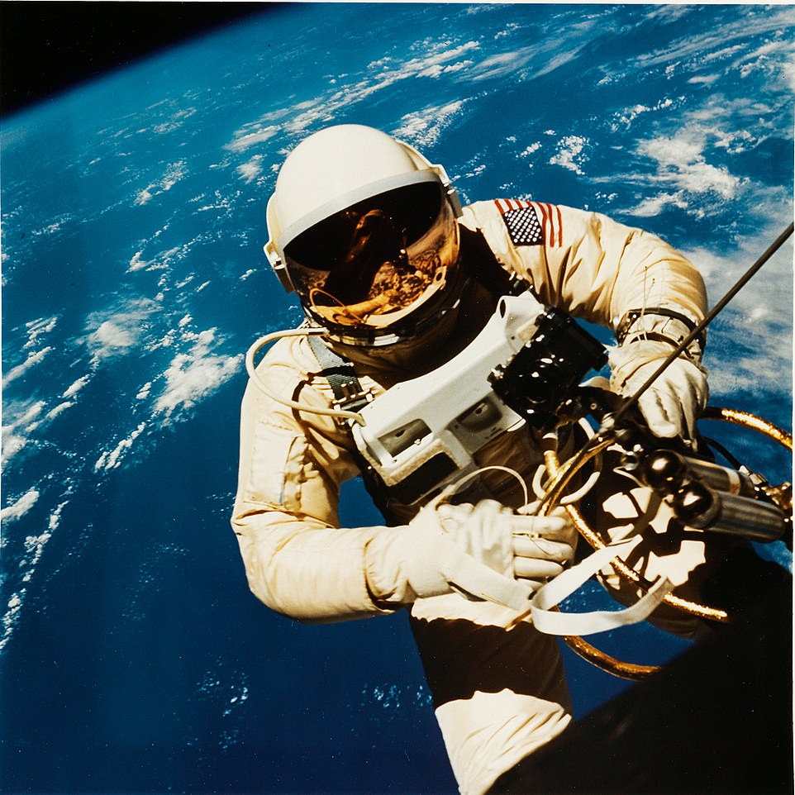

*During the numerous recent fabrengens of Simcha Beis Hashoeiva, which were arranged, one of them was for melamim (educators). I am posting one of the inspiring thoughts that was mentioned there by Rabbi Mendel Gordon of London. While it was for melamdim it is applicable to everyone, as indeed each parent is the main educator in their home.*

*In accord with the chassidic saying of, “As Shabbos Bereishis goes, so goes the entire year,” let this indeed inspire us throughout the year and beyond, until the coming of Moshiach tzidkeinu, may it be speedily in our days.*

Dr. Velvel Green, a”h, worked for many years for NASA. He once gave an insight in the futuristic plans that are often discussed there. While many of those plans and milestones are indeed reached, this one was on a theoretical plane.

In 1969, after the successful landing of the Apollo 11 on the moon, there was a discussion would it be possible for humans to reach other cosmic bodies. The closest planet to us is Mars, and if we landed there, the debate of are there Marians or not would finally be resolved. Then came a more hypothetical question, could we successfully send a rocket ship to the nearest star in the heaven.

The closest cluster of Stars to the Earth (excluding the sun) is Alpha Centauri, a mere 4.3 light years away, which would mean it would take some three thousand years to arrive there.

This question was predicated by disclaimers and understanding that our technology is obviously not so advanced, but the question was, what would it take to accomplish such a feat. What are the obvious obstacles that have to be addressed and solved, in order to accomplish such a noble undertaking? The scientific benefits from such an endeavor would be immeasurable and would benefit mankind in so many ways.

So a task force was set up to study this and after a while they came back with their report.

As noted our expertise is not up to par to build such a spacecraft, they prefaced their response. However, it is not just that we would have to have better insulation on the outside of the spaceship; we will be facing multiple challenges from various angles. They mentioned some of the most obvious ones:

Where will you store oxygen for so many thousands of years? Because then you would have to send off a rocket ship as large as an ocean.

Even if we figure out how to create or recycle the air that it should be viable oxygen, how are we going to store enough food to last so many years?

Even if we come up with a new agricultural system to grow food on the rocket ship and make an entire ecosystem, for how many people are we going to have to make room?

Obviously we are going to have to send up couples, and where are we going to bury those that pass away during the thousands of years of flying time, and what are we going to do with the waste they will create and accumulate over this extremely long period of time?

These and similar questions demonstrate that the feasibility of such an undertaking is beyond our scope.

However, some scientists were not persuaded on abandoning such a great undertaking, because of our own lack of knowledge. They persuasively argued, that twenty or thirty years ago the concept of landing a rocket ship on the moon was also considered an impossibility, and it was beyond our scope. Yet, we in the field of Science are not persuaded by what others think; we follow Science, and we succeeded what many thought was a fool’s dream! So here too, take away your personal thoughts and let us focus on the scientific solutions!

At that point one of the members of the commission spoke up:

Our distinguished colleague has a valid point; we have to govern our decisions on science, and not on human emotions. Yet over here, part of the problem is that we are not dealing with machines that are on automation, we are discussing sending up humans. We all understand that those that we choose to begin this project are not the ones that are going to finish the project, they and their children and grandchildren etc., are all going to pass on years before the rocket ship reaches its destination.

So I have a question for all to ponder. We are going to train the cream of the crop, the best of what we have to begin this journey for the sake of mankind. My question is what is going to guarantee us that in two thousand years from now the descendants of these noble scientists are going to continue following the commands and instructions from mission control?

They may say, we are the ones flying this ship, and we, unlike those creatures who live on something called the earth, are the experts in outer space, so why should we follow their guidelines and instructions. We think that instead of flying towards Alpha Centauri, we should alter course and land someplace else. In our understanding that will be more adventurous as well as beneficial!

**How is Science going to answer that?**

That, my friends is the predicament some of you may find yourselves, explained Rabbi Gordon. This is the mission of you educators and parents. The Torah was given to us over three thousand years ago and it included a manual of operation instructions for us to follow; yet there can come a time that some of those that read it, may feel that they are more knowledgeable than the generation that accepted this mission. But it is the educators of each generation that transmit the truth to our charges.

It is not a question of who is smarter; this generation or that generation. The Torah was given by Hashem, the Creator of all time, and was given for all time. The Torah is eternal. Mission control is not some earthlings, but is Hashem Himself and therefore, even if we may think that we are smarter and more sophisticated than our ancestors, we are honest enough to admit that our understanding is not close to the understanding of the Creator, and how fortunate we will be when we follow His guidance.

*Reprinted from the Parshas Bereishis 5779 email of The Weekly Story by Rabbi Sholom DovBer Avtzon. Rabbi Avtzon is a veteran mechanech and the author of numerous books on the Chbad Rebbeim and their chassidim. He is available to to speak or farbreng in your community and can be contacted at avtzonbooks@gmail.com*

*Reprinted from the Succos 5780 email of the Chabad of Great Neck, NY.*

**The Atmosphere of Noah’s Ark**

**And the Future Messianic Era**

**From the Talks of the Lubavitcher Rebbe**

**Rabbi Menachem Mendel Schneerson, Zt”l**

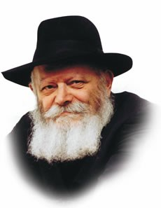

This week's Torah portion, Noach, contains the narrative of Noach and the Great Flood which covered the earth in his generation.

After many months "at sea" in his ark, Noach opened the window to check on the sodden and water-logged world, to see if it had finally dried.

"In the second month, on the twenty-seventh day of the month," Noach found that the earth was indeed "perfectly dry."

It was then that G-d spoke to Noach and issued the command: "Go forth from the ark, you, and your wife, and your sons, and your sons' wives with you."

Why did Noach need a special command from G-d to induce him to leave the cramped quarters he had endured for so long? Why didn't Noach exit the ark joyously of his own accord as soon as he saw that the land was dry?

Noach's reluctance to leave may be understood in light of the great miracle which occurred inside the ark itself.

All the animals within it, the ferocious and the tame, miraculously co-existed peacefully with each other, contrary to their natural inclinations and instincts.

Just imagine the hundreds of different species sharing their relatively small living space (the entire ark was only three hundred cubits long and fifty cubits wide) for an entire year -- yet no animal caused harm to another the whole time!

Chasidic philosophy explains that the atmosphere in Noach's ark was akin to what will happen when Moshiach comes, when "the lion will lay down with the lamb" and peace will reign on earth.

Noach, his family and all the animals in the ark enjoyed a peace which will return to the world only with the Final Redemption and the Messianic Era, speedily in our day.

Understandably, therefore, Noach was hesitant to leave the peaceful environment of the ark for the natural order that had existed before the Flood.

The earth may have finally dried, but Noach preferred the Messianic existence within the confines of the ark to returning to the vast expanse of dry land which beckoned.

He therefore needed G-d's encouragement to disembark, to begin the next chapter in mankind's history and to fulfill the purpose of creation -- the establishment of a dwelling place for G-d down below in the physical world.

"Go forth from the ark" is likewise G-d's counsel to every Jew.

The Jew is enjoined to go out of his "four cubits," no matter how rarefied and holy, to fill the earth with G-dliness and holiness according to Divine plan, through the learning of Torah and the observance of mitzvot.

*Reprinted from the Issue #337 of L’Chaim Weekly (Parashat Noach 5755/1994)*

**Rabbi Berel Wein**

**On Noach**



The Torah, in this week's reading, describes the rainbow as becoming the symbol of G-d's covenant with the humankind, that the world will not be destroyed by another flood. The appearance of the rainbow in the narrative of Noach and his emergence from the ark does not mean that the rainbow was created then. According to rabbinic tradition and the unchanging laws of nature, the rainbow existed from the time of original creation itself. What is significant is that the Torah points out to Noach that the rainbow now has a great significance to humanity and is not to be observed and thought of as being merely another of the great many phenomena that we call nature.

Rather, when human beings see a rainbow, they should be reminded of G-d's covenant with us and how we are all descended from one family that was the progenitor of humankind, as we know it today.

One of the interesting things about the rainbow is that when Jews view it, they are bidden to recite a blessing. This is meant to teach us that the wonders of nature are constant reminders of our relationship to our Creator and our obligations that that entails.

Because of this, Jewish tradition also teaches us that we are not to stare at length or directly at a rainbow because the rainbow represents G-d's presence in our world and should not be subject to prolonged stares.

This lesson is true in all areas of human life and in our relationship to nature. Pantheism promulgated the idea that nature itself is G-d. That is a misrepresentation of the true relationship between the Creator and what was created. Judaism teaches us that we are to see the wonders of the planet that we inhabit as part of G-d's scheme in creating the world and that we react to seeing those wonders through the prisim of the Torah that the Lord has granted to Israel.

Viewing nature without Torah insight and background is again reverting to pantheism. That is the meaning of the Mishnah in Avot that one should not interrupt one's study of Torah in order to admire a beautiful phenomenon of nature. Nature is to be viewed through knowledge and understanding of Torah and not as something that is distinct and unrelated to Torah and its values.

Seeing nature devoid of any moral backdrop diminishes the wonders of nature and the grandeur of the world in which we live. A rainbow without the message of the L-rd to Noach loses much of its beauty and a great deal of its meaning.

In the Talmud we find that great and noble people were themselves compared to the rainbow, because in a noble person one can also link the nature of the Creator that fashions that person. Everything in life and in nature, as well as our judgment of human beings should always be viewed from the perspective of Torah and eternity.

*Reprinted from this week’s website of Rabbiwein.co*

**Rav Avigdor Miller**

**On Orthodox Friction**



**QUESTION**: What's the cause of the friction between various Orthodox groups and how are we to overcome this problem?

**ANSWER:** Why ask about between Orthodox groups?! Ask: what's the cause of the friction between a man and his wife! What's the cause of *any* friction? It's going on all the time. I know just well. I'm getting phone calls all the time.

And the answer is: human nature. People have various attributes of character within themselves, and no one is like anyone else. And that's not an accident of nature; Hakodosh Boruch Hu intentionally made people different in order to perfect them in learning how to deal with others.

That's why it's so important to be married. A man and a woman are two different nationalities. נשים עם בפני עצמן הן - "Women are a nation of their own" (Shabbos 62a). And that means men are their own separate nation too.

When you get married and soon after the *chuppah* you realize that you are very different from your spouse, don't think that it's a mistake. Hashem made you different on purpose. That's why you got married; so that you should have to learn how to get along with your wife. And a wife must learn how to get along with her husband.

And they perfect themselves as the years go by; they become better and better. But anyone who is careless will tend to cause friction. When two bodies rub together, there's going to be friction. And friction causes heat, and heat causes irritation.

And therefore, it's only when people learn to lubricate themselves with kindness and patience; when they follow *da'as Torah* of how to behave, that's when there won't be any friction. So how can you ask me a question of how there can be friction? Friction between people is nothing but the *yetzer hara!*

We are in this world chiefly to get along with other people. You remember when Hillel was asked by a potential convert, "Teach me the whole Torah while I stand on one foot," so Hillel told him, "Pick up your foot and let's get busy."

And what did Hillel teach him? He told him דעלך סני לחברך לא תעביד זו היא כל התורה כולה ואידך פירושה הוא - "What you don't want people to do to you, don't do to them. That's the whole Torah. The rest is just the details" (Shabbos 31a).

And Rashi says that רוב המצוות, most of the Torah is mitzvos between a man and his fellow. Most of the service of Hashem is measured by your contact with other people; how you interact with other people. And your contact with your wife is more frequent than with strangers. A wife is like a hundred people or like a thousand people, because the interactions with your wife are much more frequent than with anyone else. And therefore, you're going to have to learn how to get along.

The reason why there's friction among Orthodox Jewish groups is the same reason that's there's friction between you and your wife. It's the same reason why there's friction between you and your neighbor. It's the same reason why there's friction with your own self.

Very many people can't get along with themselves either. They are angry at themselves, disappointed with themselves, and they fall into a mood of melancholy and even depression. So you have to learn, first of all, how to get along with yourself. And then how to get along with others.

And therefore, in answer to your question, the reason for the friction is that it's a test for mankind. And we're in this world mostly to succeed at this test.

*Reprinted from the October 24, 2019 email of Toras Avigdor adapted from Tape #834.*

**Noah’s Ark and the Yeshiva**

**By Rabbi Eli J. Mansour**

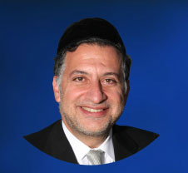

We find in Humash two different structures that G-d commanded to build: Noah’s ark, and the Mishkan (Tabernacle) in the wilderness.  Rav Yitzchak Hutner (1906-1980) noted that there is a basic, fundamental difference between these two structures.

One was built for protection, and the other for advancement. Noah had to build the Teba to protect himself and his family from the destructive floodwaters which ravaged the Earth and killed its sinful inhabitants.

The Mishkan, by contrast, was a place where Beneh Yisrael could go to elevate themselves, rise to a higher level of spirituality and strengthen their connection to Hashem. This structure served a generation that was on the highest spiritual plane.

This generation experienced miracles and stood at Mount Sinai when G-d gave the Torah. They learned from Moshe Rabbenu, and they lived a pure existence without any exposure to foreign influences. Unlike Noah entering the Teba, those who entered the Mishkan were not escaping anything. They were going to develop their souls and enhance their relationship to G-d.

Rav Hutner noted that the difference between these two structures is, essentially, the difference between the Yeshivot of yesteryear and the Yeshivot of today. In the Old World, whether it was in Europe, Syria or elsewhere, Jews lived in purity and devotion to G-d. Their communities were devout and protected from negative spiritual influences.

The boys who went to Yeshiva were like those who went to the Mishkan, aspiring to reach towering heights. In our generation, however, we live in an immoral society whose values and culture penetrate into our lives at every turn. Our communities, unlike those of earlier generations, are exposed to the spiritually hostile influences of the surrounding society.

And thus the Yeshiva in our time serves not only as a Mishkan, but, primarily, as a Teba, a source of protection. It allows our children to spend their formative years in a spiritually safe environment, shielded from the corrosive influences of contemporary society.

Hence, unlike in generations past, Yeshivah education is not an option, but a vital necessity. We cannot imagine Noah trying to survive the flood outside the Teba. By the same token, it is impossible to expect impressionable young souls to survive the “flood” of immorality and decadence that has overtaken the world in our time if they remain outside the insular, protective framework of the Yeshiva.

This is a vital message for not only parents, but also educators. The Hazon Ish (Rav Avraham Yeshaya Karelitz, 1878-1953) cautioned that in our times, the decision to expel a student from Yeshiva requires a 23-member Bet Din. According to Halacha, life-and-death cases cannot be brought before a standard, three-member court; they require the adjudication of 23 expert judges. In our day and age, the Hazon Ish said, expelling a student is a matter of spiritual life and death. This is not a decision that may be made on a whim.

Unfortunately, many schools today are so caught up with preserving their reputations that they forget this vital message. Administrators must understand that in our society, where an expelled student could end up in a street or in public school, expulsion can very well become a spiritual death sentence. Such decisions must be made with the utmost caution and discretion, and with a keen awareness of the vital protective role that today’s Yeshivot fill.

*Reprinted from this week’s website of the Edmond J Safra Synagogue of Brooklyn website.*

**The Shmuz onParshas Noach**

**Bitachon and Effort-**

**Finding the Balance**

**By Rabbi Bentzion Shafier**

**Founder of TheShmuz.com**



## The Chazal

The *tayvah* was 600 *amos* (cubits) long, 50 *amos* wide, and 30 *amos* tall.

## Question

Why do we need to know what the dimensions of the *tayvah* were?

## Answer

The vessel couldn’t hold all of the animals in creation. Yet, Noach was obligated to do as much as he could, only then was he allowed to rely on the miracle.

## Life lesson

This is an operating principle in life. We must use this world, in the “*derech HaTeveh* (the ways of nature), all the while knowing that HASHEM controls the outcomes.

*“This is how you should make the ark: three hundred amahs long, fifty amahs wide and thirty amahs tall.”* Bereishis 6: 15

HASHEM appeared to Noach and told him that the world had turned to wicked ways, and it was to be destroyed by a flood. HASHEM commanded Noach to build a *tayvah* (an ark) so that he and his family would be saved.

The Torah then lays out the dimensions of the ark in exact detail: the length, the height, the width, and the material it was to be made from. The commentaries ask: why do we need to know the exact dimension of the ark that Noach built?

All the animals couldn’t possibly fit into the Tayvah

*Rabbenu Bachya* answers that the Torah delineated the size of the *tayvah* to teach us a lesson. Assuming that an amah is a measurement of approximately two feet, the entire construction was not large: 600 feet long, 100 feet wide and 60 feet tall. When we put those dimensions into perspective, it becomes obvious that all of the animals in the Creation, could not possibly fit into such a small area.

Noach was commanded to gather up every species of living creature – from the gorillas swinging in the trees to the cows eating the grass, from the birds flying in the sky to the reptiles creeping on the ground each was to be represented on the Tayvah. So many animals could not possibly fit into so small a craft. Even fifty such *Tayvahs* couldn’t house all the animals in existence, let alone the food and supplies needed to support them for almost a year’s time.

Rabbenu Bachya explains that Torah described the dimensions to teach us a pivotal concept: Man must act in the “*Derech HaTeveh,*” the ways of the world. Man is commanded to do that which is in his power, and only when he has exhausted all in his means, is he allowed to rely on a miracle. Noach couldn’t possibly have built a vessel large enough to house all living creatures. Yet he couldn’t just do nothing. He was commanded to do as much as he could, and only then rely on the miracle to fill in the rest.

**Operating principle in our lives**

This concept is the operating principle for our lives. We are obligated to take this world very seriously, all the while knowing that HASHEM is the One who controls everything. We are obligated to work very diligently at earning a living, knowing that the exact amount of money we are to make that year was set on Rosh Hashanah. We are obligated to seek out medical help – not just any doctor, but the best that is available to us – all the while knowing that our health and well-being are completely in HASHEM’s hands.

## Why do we need to know the dimensions of the Ark?

Our Hishtadlus (our efforts) and our Bitachon (our trust in HASHEM) have to be balanced. A person must use the *Derech HaTevah*, acting as if my efforts will determine the outcome, all the while knowing that everything is entirely controlled by HASHEM.

But finding the balance between proper *Hishtadlus* and *Bitachon* is very difficult. Invariably, we either put too much stock in our efforts, our business acumen, and our abilities to get things done… or we act irresponsibly in our *Hishtadlus*, saying, “HASHEM will provide,” even though we haven’t put in adequate effort. The proper balance can be better understood with a Moshol.

Walking the tightrope

When the tightrope walk was first introduced to the circus, it was an exciting act to watch. A highly skilled acrobat would perform devilishly frightening dance steps while walking on a thin wire suspended high up in the air. However, everyone knew that the danger was limited. Even if the performer slipped, there was always a safety net below to catch him.

Somewhere in course of circus history, the net was eliminated. Now, the acrobat was asked to walk the same distance and perform the same feats, but with one distinction: if he were to fall, there would be nothing there to catch him.

Imagine the electricity in the air the first time that act was performed! There was the tight rope walker, doing the same act that he’d performed thousands of times before, but now one slip, one misstep, and he’d fall to his death on the concrete below. No matter how many times he’d walked the high wire before, this time was different. He was galvanized by the excitement, exhilarated by the danger.

That is an apt parable to our Hishtadlus. We have to go about life like that tightrope walker, taking our efforts very seriously, and acting as if the outcome is completely dependent upon them. Our attitude has to be, “If I don’t put in the adequate exertion I will fail and fall to the concrete below.” All the while, though, we must know that there *is* a safety net. HASHEM is there to help and support us, and even more, HASHEM completely directs every action in our lives. This is the proper balance that we need to strike between putting in our own efforts and trusting in HASHEM’s close involvement.

*Reprinted from this week’s website on TheShmuz.com This is an excerpt from the*[*Shmuz on the Parsha book*](https://theshmuz.com/product/shmuz-on-the-parsha-book/)*.*

**Thoughts that Count**

*I have set My bow in the cloud, and it shall be a sign of My covenant between Me and the earth...and I will remember My covenant...and the waters will no more become a flood to destroy all flesh* (Gen. 9:13-15)

Why does the rainbow signify that G-d won't bring another Flood?

Before the Flood, the clouds in the sky were thick and dense, obscuring the light of the sun.

The Flood, which cleansed and purified the earth, also refined the clouds and made it possible for the rainbow to be observed, a phenomenon caused by the sun's rays.

The rainbow, a product of the process of purification, is therefore symbolic of the Final Redemption, which will come about through the refinement and elevation of the physical world.

Its appearance in the sky is a sign of the imminence of Moshiach, as stated in the Zohar: "When a rainbow appears with its shining multicolored hues -- await the arrival of Moshiach."

The Messianic Era, in which the world will reach unprecedented levels of holiness and refinement, is the culmination of that process of purification. *(The Lubavitcher Rebbe, Parshat Noach, 5721)*

*And G-d descended to see the city and the tower* (Gen. 11:5)

Why does the Torah tell us that G-d "descended" to investigate? Isn't G-d All-Knowing and All-Seeing, present in all worlds and omnipotent?

Rather, these words contain a lesson for mankind:

One must always investigate a matter thoroughly and never pronounce judgment on something one has not personally witnessed. *(Our Sages)*

*For the earth is filled with violence* (Gen. 6:13)

G-d could not have chastised the generation of the Flood with monetary punishment, for such punishment holds meaning only when a person has worked hard to acquire his money.

A thief, however, is not unduly disturbed when his money is confiscated, for he merely stole it from another individual. *(Melo HaOmer)*

*Reprinted from the Issue #337 of L’Chaim Weekly (Parashat Noach 5755/1994)*